### **1. Overview:**

This report documents the actions taken to add researcher9 to the system, assign file ownership, add them to a supplementary group, and ultimately delete the user when they left the organization. These tasks are part of the employee management process.

### **2. Task 1: Add researcher9 to the System**

**Objective:** Add the new employee researcher9 to the system and assign them the research_team as their primary group.

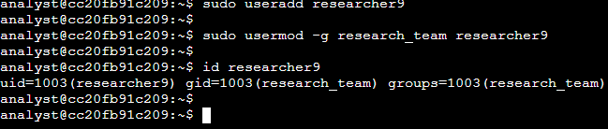

**Command to Add User:**  
sudo useradd researcher9

**Command to Add researcher9 to research_team Group (Primary Group):**  
sudo usermod -g research_team researcher9

**Verification Command:** To verify that researcher9 has been successfully added and is in the correct primary group:  
  
id researcher9

## **Task 2. Assign file ownership**

The new employee, researcher9, will take responsibility for project_r. In this task, you must make them the owner of the project_r.txt file.

The project_r.txt file is located in the /home/researcher2/projects directory, and owned by the researcher2 user.

* Use the chown command to make researcher9 the owner of /home/researcher2/projects/project_r.txt.

**Objective:** Transfer ownership of the project_r.txt file from the researcher2 user to researcher9.

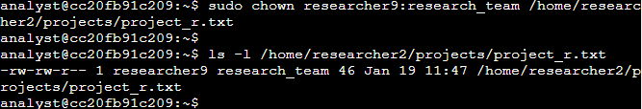

**Command to Change Ownership of project_r.txt to researcher9:**  
sudo chown researcher9:research_team /home/researcher2/projects/project_r.txt

**Verification Command:** To verify the ownership of the file:  
  
ls -l /home/researcher2/projects/project_r.txt

## **Task 3. Add the user to a secondary group**

A couple of months later, this employee's role at the organization has changed, and they are working in both the Research and the Sales departments.

In this task, you must add researcher9 to a secondary group (sales_team). Their primary group is still research_team.

* Use the usermod command with the -a and -G options to add researcher9 to the sales_team group as a secondary group.

**Objective:** Add researcher9 to the sales_team group as a secondary group while keeping research_team as their primary group.

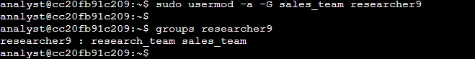

**Command to Add researcher9 to sales_team:**  
sudo usermod -a -G sales_team researcher9

**Verification Command:** To verify the groups that researcher9 belongs to:  
  
groups researcher9

## **Task 4. Delete a user**

A year later, researcher9, decided to leave the company. In this task, you must remove them from the system.

1. Run a command to delete researcher9 from the system:

**sudo userdel researcher9**

**Verification Command**: To verify that the user has been deleted, use:

**id researcher9**

This command will output the following message:

Userdel: Group researcher9 not removed because it is not the primary group of user researcher9.

This is expected.

***Note:*** *When you create a new user in Linux, a group with the same name as the user is automatically created and the user is the only member of that group. After removing users, it is good practice to clean up any such empty groups that may remain behind.*

1. Run the following command to delete the researcher9 group that is no longer required:

**sudo groupdel researcher9**

**Verification Command**: To verify that the group was deleted, use:

**getent group researcher9**

If the group was successfully removed, this command should return no output.

**Objective:** Remove the user researcher9 and their associated group after they left the organization.

